CSE140L Spring 2020 Lab 4

Due 11:59pm 1 June 2020

1. Objective: Design an encrypter which reads a message from a range of locations in a register file (memory) in 8-bit ASCII format, encrypts the lower 6 bits with a 6-bit PN code, and writes the resulting encrypted message into another range of locations in the same register file.

(In Lab 5, we shall decrypt a given encrypted message.)

2. Deliverables:

2.1 Working Verilog model, built around a state machine for control/sequencing and a simple data path.
2.2 Screenshots of waveform viewer and transcript, demonstrating that it worked properly.
2.3 Screenshot of Quartus RTL Viewer, showing top level block diagram / schematic of your design.

3. Provided:

3.1 Verilog test bench

3.2 Shells for top level Verilog module, register file (data memory)

4. Details of required functionality:

4.1 The testbench will store a given 8-bit ASCII character string (which you or the TAs can easily change) as the original unencrypted (bare) message into addresses 0 through N, where N<50, of a 128-element 8-bit-wide register file (data memory) you will design as a module within your encrypter.

4.2 Your encrypter/encoder will prepend this message with a prefix comprising at least 7 bytes of ASCII underscore = 0x5F. The test bench will load the desired prefix length into address 61 of your register file. If the number is 7 or lower, prepend 7 ASCII underscores. If the number is 12 or greater, prepend the given number of ASCII spaces, but note that some (or even all) of the end of your message may be truncated.

4.3 Your encrypter will append enough ASCII space characters to the end of your message to pad the total length of prefix plus message to 61 bytes. If the prefix plus message length exceeds 61 bytes, your encrypter will truncate it at 61 bytes.

4.4 Your encoder will bitwise XOR the lower 6 bits of the first 0x95 (ASCII 8-bit underscore) against the given 6-bit LFSR starting state, which the testbench will have stored in register memory location 63. Write this new byte into memory location 64.

4.5 Now bitwise XOR each subsequent byte of the prefixed and padded message with each new state of the LFSR, for the LFSR feedback bit pattern the testbench has stored in register memory location 62. Write each successive byte of the encrypted message into locations 65, 66, ... , 125.

4.6 Compare your results against those given by the testbench.

4.7 Your design must be buildable/synthesizable. In particular, this means you will have to generate address pointers to read from and write to the data memory and data bus connections into and out of the data memory. You are not allowed to “drill down” inside, as I do from the test bench or in my demo design. Think about how the data path is built in a typical RISC (ARM, MIPS, SPARC, etc.) processor.

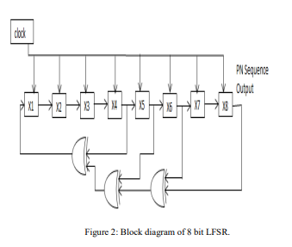
Sample 8-tap LFSR (see Powerpoint for a 6-tap example)

If we number the bits X0 through X7 instead of the X1 through X8 shown, we can express the feedback pattern as:

X7, X5, X4, X3 = binary 1011_1000 = 0xB8.

Your 6-tap LFSR should be able to work with any combination of feedback taps (the testbench reserves the right to use any of the six maximal-length patterns – see sample code for the list).

Sample sequence, x[8:1] (we use x[7:0], but works the same except the index shift)

00000001
00000010
00000100
00001001
00010010

